
June, 2026

Bastion • École Élementaire • Elementary School
School District No. 83 (North Okanagan-Shuswap)

Principal’s Message

As we finish of the 2025-2026 school year, it is always a bit bittersweet. After spending close to 180 days together (that’s 1074 hours and 64,550 minutes!!!) we say farewell to your children for a couple of months. Our staff invests their hearts, lives and expertise into your children, delivering their finest instruction and support, and coming along side them in relationship. Though we too are excited for the upcoming break, it’s hard to say goodbye as well!

With that, we hope and trust all families enjoy a well-deserved summer break. Time for some relaxation and fun together. As you likely know, we’ve got some staff that are saying farewell as well. Most especially, we bid a very fond farewell to Ms. Sheri Webster, our beloved Kindergarten teacher who is polishing off a masterful career. If you were fortunate enough to have a child in her class, you will know her passion and skill for her craft is exceptional, and her ability to help children develop literacy and numeracy skills has helped many many children in her years as a teacher. We send Sheri off to retirement with our warmest wishes!
We also will bid farewell to Mrs. Rita Tedesco, who was with us for just a year. All the best as she transitions to Hillcrest Elementary in the role of Vice Principal. Others leaving us are:

Erin McBean: Learning Resource Teacher
Mme. Kailey Cannon: Grade 2 French Immersion co-teacher
Mrs. Carol Hall: French Immersion music teacher to Kindergarten
Mr. Austin Mueller: French Immersion Kindergarten Teacher – Mr. Mueller has been with us 7 years!
Mme. Valerie Viens: Maternity Leave
Mrs. Denise White: ENG K/1 co-teacher
Mme. Isabelle Trembley: French Immersion CEA
Mrs. Marwah Sadeq: CEA
Mrs. Erin Warden: Early Childhood Educator
Mrs. Hannah Spencer: CEA
Mr. Muhammed Davud: Custodian
Ms. Francine Narcisse: (IEW)

And lastly, as you likely know, I will be leaving this wonderful community to take up a Principalship at Sorrento Elementary, in my home community. I have loved the Bastion community and wish all of you the very best! Bastion will be in excellent hands under the leadership of Mrs. Raelyn Larmet (Principal) and Mrs. Sharon Mitchell (Vice-Principal).

All the very best!!

Heather Gobbett

Principal

BASTION PAC news:
I’d like to extend a hearty THANK YOU to the parent advisory committee of these past years. Your time serving the school has been deeply appreciated and we are grateful for the incredible efforts you’ve made to enhance the Bastion community. For a copy of the AGM report, please click this link: https://bas.sd83.bc.ca/pac-meeting-agendas-and-minutes
We are excited to have voted in a new Parent Advisory Committee meeting for the fall 2026. Welcome to the following members
President: Colin Underwood
Vice President: Emma Ryan
Secretary: Krista Penner
Treasurer: Kellie McMillan
DPAC: Katie Monai/Larissa Limage
Fundraising: Paige Keetch
Fun Food Coordinator: Devin Hartigan
Social Media Coordinator: Vanessa Morris

Contact information over summer:

If you have information to send to us, please contact bas@sd83.bc.ca over the summer. Please know that it won’t be monitored regularly as we will likely be …

The office will re-open on Monday August 31, 2026. New registration Day is Tuesday September 1

Moving? Please let us know if you plan to move and enrol your child at a different school for the upcoming school year. We hope that we get to see all of our returning students in the fall, but if you have other plans, please confirm that with us in the office) at (bas@sd83.bc.ca) as soon as you are able to do so. Thank you!

Bell Times next year:
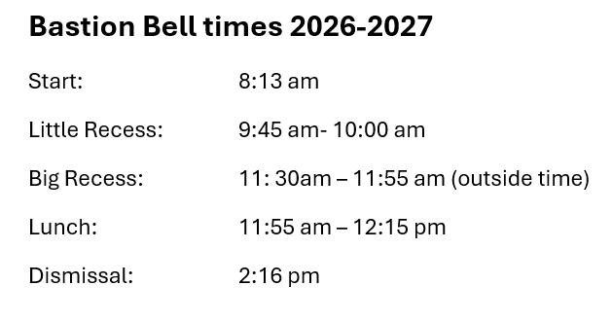

First Days back at school
Monday August 31: Bastion School office opens at 8:00am

Wednesday Sept. 9:
- Students in Grades 1-6 are back for 3 hours (early dismissal at 11:16 am)
  - Students may likely return to home rooms this day, but plans will be communicated before school begins

Thursday Sept. 10 & Friday Sept. 11
- Students in Grades 1-6 will be grouped (plans to be communicated before school starts); but not in homeroom placements
- Kindergarten Gradual entry (letter will be send home in June 2026)
Monday Sept. 14:
- First day of homeroom classes

